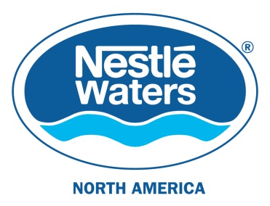

Contact: Jane Lazgin
(203) 863-0240
jane.lazgin@waters.nestle.com

Nestlé Waters North America Statement
Cascade Locks, Ore., May 2, 2016 –

• Nestlé Waters North America (NWNA) is pleased the International Bottled Water Association (IBWA), of which we are a member, is actively opposing Measure 14-55 as it arbitrarily singles out the bottled water industry.

• NWNA has provided funds to the International Bottled Water Association, to help fund their efforts to oppose Measure 14-55. IBWA has reported all the sources of funds which they have dispersed to the “No on 14-55 campaign”.

• We respect and comply with regulations and reporting for all our project locations, including our financial support to oppose to Measure 14-55.

• As this is a measure to ban our proposed business in Hood River County, we should naturally be engaged in the debate. We are very pleased that IBWA is leading this effort for us, and that a number of local individuals and organizations have also supported the opposition of this measure.

